**ASSIGNMENT 1**

**BATCH NO : B1-1M3E**

**NAME : ABINAYA.C (Reg No : 413019104002)**

**Make a smart home in Tinkercad , Using 2+ sensors , Led , Buzzer in single code and circuit**

**Circuit Diagram**

**Before Started Simulation**

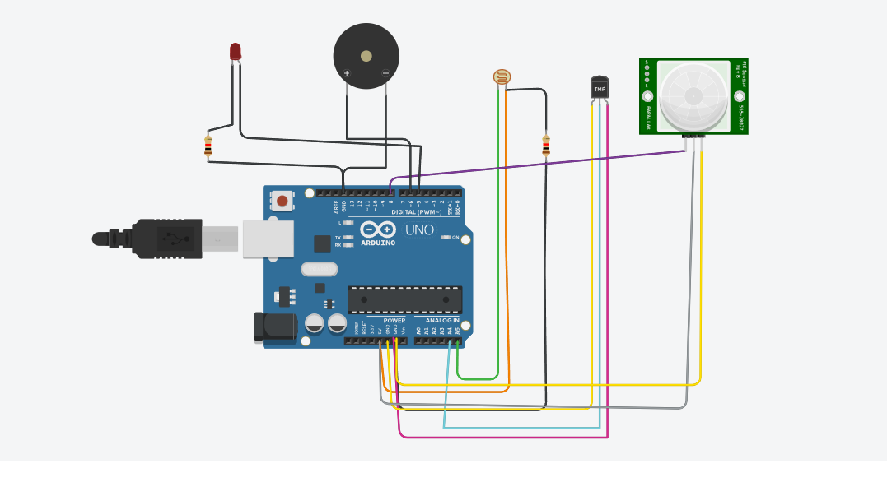

**After Started Simulating**

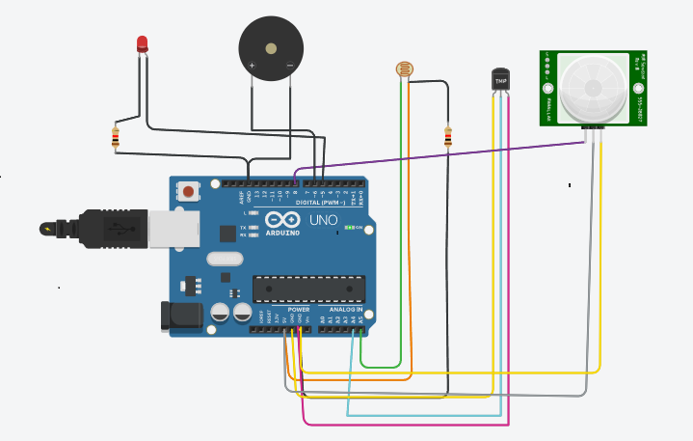

**Circuit Code**

**int trigger_pin=2;**

**int echo_pin=3;**

**int buzzer_pin=10;**

**int time;**

**int distance;**

**float x,y,z,temp;**

**void setup()**

**{**

**Serial.begin(9600);**

**pinMode(trigger_pin,OUTPUT);**

**pinMode(echo_pin,INPUT);**

**pinMode(buzzer_pin,OUTPUT);**

**pinMode(8,INPUT);**

**pinMode(5, OUTPUT);**

**pinMode(6,OUTPUT);**

**pinMode(A5,INPUT);**

**pinMode(A4,INPUT);**

**Serial.begin(9600);**

**}**

**void loop()**

**{**

**x=digitalRead(8);**

**y=analogRead(A5);**

**z=analogRead(A4);**

**Serial.println(x);**

**Serial.println(y);**

**Serial.println(z);**

**temp=(double)z /1024;**

**temp=temp*5;**

**temp=temp-0.5;**

**temp=temp*100;**

**if ( (x>0) )**

**{**

**if ((y<550)&&(temp<30))**

**{**

**digitalWrite(5,HIGH);**

**digitalWrite(6,HIGH);**

**}**

**else if((y<550)&&(temp<30))**

**{**

**digitalWrite(5,HIGH);**

**digitalWrite(6,LOW);**

**}**

**else if((y>550)&&(temp>30))**

**{**

**digitalWrite(5,LOW);**

**digitalWrite(6,HIGH);**

**}**

**else if((y>550)&&(temp<30))**

**{**

**digitalWrite(5,LOW);**

**digitalWrite(6,HIGH);**

**}**

**}**

**else if((y>550)&&(temp<30))**

**{**

**digitalWrite(5,LOW);**

**digitalWrite(6,LOW);**

**}**

**}**